OCEANA COUNTY

**JUNIOR MARKET**

**GEESE RECORD BOOK – 2023**

**(ages 5-7)**



As a member of the Junior Market Animal Project, you are required to submit your records as part of an educational project notebook in order to show your animal at the Oceana County Fair. **This notebook must be shown to the Poultry Superintendent or designated Small Market Weighmaster at the time of weigh-in and then entered by you in the Educational Notebook Division at the Oceana County Fair on Entry Day.**

**IF YOU ARE A LITTLE BUDDY PLEASE CHECK HERE: _____**

**My big buddy is: _________________________________________**

**NUMBER OF YEARS IN PROJECT: __________**

**AGE: __________**

Your age you enter depends on how old you were on January 1, 2023.

Use this sheet as the first page of your project record book. Fill it out completely.

**Please print or type neatly**.

# NAME ____________________________________________________________________________

4-H CLUB _________________________________________________________________________

LEADER __________________________________________________________________________

##### DATE RECORDS STARTED ___________________ DATE ENDED ____________________

## JUDGE’S SCORE/COMMENT SHEET

## (PLEASE DO NOT REMOVE, PLACE THIS SHEET IN SHEET PROTECTOR OR GLUE TO COVER). This sheet must be kept free for the judge to write their comments.

## This sheet should help each 4-H’er understand their ribbon placing.

## A. Specific educational value or worth

## ___ All questions were answered completely

## ___ All calculations were correct

## ___ Calculations were incorrect

## ___ Questions were not answered (missed questions)

## B. Notebook contains all project records

## ___ Notebook contained all project records and were fully completed

## ___ Notebook contained additional project related information (research

## materials etc.)

## ___ Project records were incomplete

## ___There was no additional project related information

## C. Accuracy, neatness and general appearance

## ___Notebook was neat in appearance (typed/hand printed)

## ___Notebook pages were clean and stain free

___Notebook pages were in order and complete

___Notebook was difficult to read and messy

__Notebook had wrinkled and stained pages

Other Comments: _______________________________________________________

______________________________________________________________________

______________________________________________________________________

JR Market Geese- 2023 Page 2

## OBJECTIVES

1. Develop desirable work habits, sportsmanship, and ability to cooperate and express ideas through participation in projects, discussions, method demonstrations, judging teams, and exhibits.
2. Experience the pride and responsibility of leasing/owning & caring for poultry.
3. Learn how to feed, fit, show, breed and raise poultry.
4. Learn proper handling procedures to prevent injuries to 4-H members and their poultry projects.
5. Appreciate and use scientific information in poultry production and marketing.
6. Improve knowledge of grading, marketing and merchandising of poultry and poultry products.
7. Improve knowledge of the nutritive value of poultry meat and eggs and how they contribute toward good health.
8. Learn the importance of the poultry industry to the local, state, and national economies.
9. Acquire information on the opportunity that poultry offers as a career.

This record book is part of your Junior Market Geese project. By keeping records up-to-date you will be able to see how much progress you make as you set goals and work to accomplish them. Write or type neatly and clearly. Please keep the pages in order. Feel free to add extra pages at the end of your notebook. Pictures are a required part of your notebook. Taking pictures of your project animal throughout the project will indicate how your animal has grown and developed. Add pictures to your notebook on a separate piece of paper.

SCORING CRITERIA

The following breakdown will be used during the judging process of all market livestock notebooks.

A. Specific educational value or worth **30%**

B. Creative way of showing what has been learned **10%**

C. Notebooks contains all project records **50%**

D. Accuracy, neatness and general appearance **10%**

The Oceana County Agricultural Society encourages parent assistance with your project and project notebook.

**If a parent or adult helped you in filling out your notebook** please have them sign below that the answers are YOUR answers and that they assisted you in writing of the answers and understanding of the questions only.

_____________________________________________________________________________

(Signature of person helping with notebook)

_____________________________________________________________________________

(Signature member)

JR Market Geese- 2023 Page 3

**PROJECT INFORMATION**

Describe the type of geese being used in this project. List breed and variety.

______________________________________________________________________________

______________________________________________________________________________

______________________________________________________________________________

______________________________________________________________________________

## WEIGHT CHART

|  |  |  |
| --- | --- | --- |
| Date | Age | **Weight** |
|  |  |  |
|  |  |  |
|  |  |  |
|  |  |  |
|  |  |  |
|  |  |  |

**FINAL WEIGHT___________ AGE__________ DATE___________**

JR Market Geese- 2023 Page 4

## EXPENSES

##### (A) Cost of goslings $_______________________

|  |  |  |  |
| --- | --- | --- | --- |
| **DATE** | LBS. OF FEED | VARIETY | COST |
|  |  |  | **$** |
|  |  |  |  |
|  |  |  |  |
|  |  |  |  |
| **(B)** |  | **TOTAL SPENT ON FEED** | **$** |

|  |  |  |
| --- | --- | --- |
| **DATE** | OTHER EXPENSES, VET, SUPPLIES, HOUSING, ETC. | COST |
|  |  | **$** |
|  |  |  |
|  |  |  |
|  |  |  |
| **(C)** | **TOTAL SPENT ON OTHER EXPENSES** | **$** |

##### GRAND TOTAL OF ALL EXPENSES (TE): $ _______________________

**(total of A, B and C)**

**_______________ ÷ _________________ = __________________________________________**

Total Expenses **(TE)** Final Weight **(FW)** Break Even Price **(BE)**

(or total cost per pound to raise your animal)

***\*\* have your parent, leader or an older teen in your club help you figure out your breakeven price. The breakeven price is the price that you need to get at the***

***Junior Market animal auction in order to not lose money on your market project. \*\****

JR Market Geese- 2023 Page 5

**ANIMAL CARE MANAGEMENT**

The 4-H SMAA Committee requires all4-H Market Livestock members to complete the “Journal of Care” so the judge may see the time, effort and care you have put into learning about your animal. What did you do to prepare for Fair each month?

* **Feeding and watering practices**
* **Health practices and medicines (vaccinations, etc.)**
* **General Management (building a cage, cleaning living area, feed pans, etc.)**

**MAY-JUNE**

**JULY-AUGUST**

If not housed at your home, have the property owner sign. If housed at your home, please have your parent sign.

I do attest and certify that this 4-Her has cared for this animal in a responsible manner while housed on my property. I also understand that integrity and responsibility are important to this 4-H experience.

_________________________________________ ______________

Signature of Property Owner or Parent Date

If housed on own property

JR Market Geese- 2023 PAGE 6

**MARKETING**

One of the most important parts of any market animal project is marketing. This may include writing letters and talking to prospective buyers. Color in the face, a smiling face is a good action, a frowning face is a bad action. (see the example)

**Good Marketing Practice Poor Marketing Practice**











Send a reminder to attend the auction

Go with an adult to talk to your potential buyers

Make sure to explain they are signing to be a potential buyer, they are NOT signing that they are required to buy your animal

Send a picture to your potential buyers and keep in touch with them

Don’t bother your previous buyers, they already bought from you once

Only thank those who agree to be listed as a potential buyer

**What Does Not Belong?**

In each statement one word does not belong, *X (cross)* out that word.

1. Geese have: eyes, bills, beaks, webbed feet

2. Geese eat: grasses frogs, grains, pellets

3. The people who help me take care of and learn about my rabbits are:

the veterinarian, my club leader, my parents, my dentist

4. Geese breeds: Toulouse, Emden, Muscovy, Rex

Jr. Market Geese- 2022 Page 7

**COLOR THE PARTS OF THE GOOSE:**

BILL- YELLOW WING- BROWN CROP- BLUE

EYE- GREEN SHANK- BLACK BREAST- RED

TAIL- ORANGE FOOT- PURPLE

Jr. Market Geese- 2023 Page 8

**Identify Good & Bad 4-H Actions**

Color in the face, a smiling face is a good action; a frowning face is a bad action. (see the example)

**RAISING and SHOWING a RAISING and SHOWING a**

**4-H ANIMAL *with* CHARACTER 4-H ANIMAL *without* CHARACTER**













Feed Animals on Time

Complain about the judge

Leave manure on the barn floor

Thank the judge for their time

Clean pen as needed

Ask for help

Leave animals outside without shelter

Take equipment without asking

Complete your record book honestly

Insult competitors



Jr. Market Geese- 2023 Page 9

**PROJECT INFORMATION**

**Finish the Sentences**

1. My flock always needs clean, fresh ___________________________ to drink.

2. When I grow up I want to be a _________________________________________________.

3. The best, or most fun, part of my project was: __________________________________

_______________________________________________________________________________

_______________________________________________________________________________

______________________________________________________________________________

_______________________________________________________________________________

4. The hardest part of my project was: ____________________________________________

_______________________________________________________________________________

_______________________________________________________________________________

_______________________________________________________________________________

_______________________________________________________________________________

Jr. Market Geese- 2023 Page 10

**4-H KNOWLEDGE**

**The 4-H Pledge**- *Draw a line to the picture that fills in the blank* (see the example)

***I pledge…***

HEART

HANDS

HEAD

HEALTH

COUNTRY

WORLD

CLUB

COMMUNITY



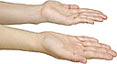





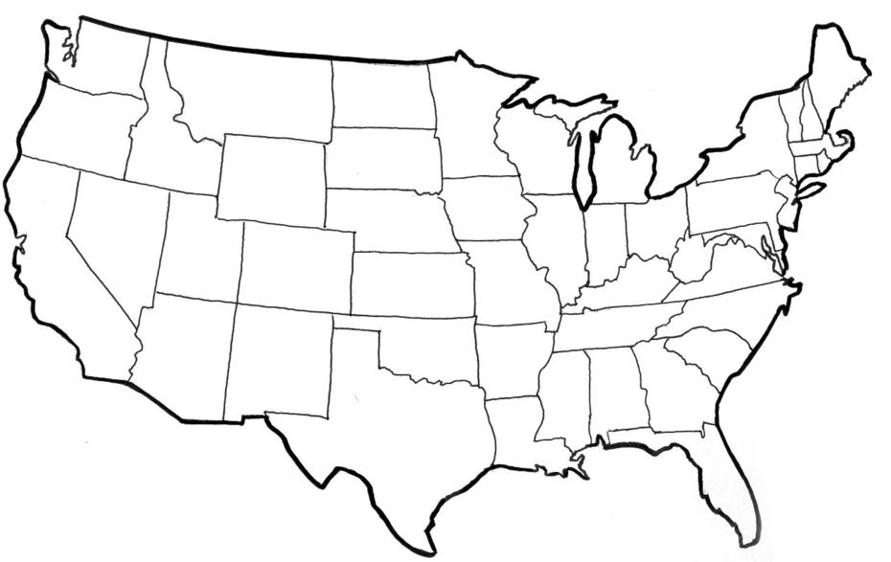







My ____________ to clearer thinking,

My ____________ to greater loyalty,

My ____________ to larger service, and

My _____________ to better living,

for my ____________________,

my _______________________,

my _______________________,

and my ____________________.

Number of club meetings held: **__________** Number I attended: **_________**

JUNIOR MARKET GEESE – 2023 PAGE 11

**MY STORY**

(Interesting things that happened to me and my animal this year, challenges, highlights of my year or ***ANYTHING*** I would like to share about my overall

experience. You can even draw a picture of you and your animals if you prefer).

***POTENTIAL BUYERS NAMES***

As part of your 4-H Small Market Livestock Project, you must personally contact at least three potential buyers before the Oceana County Fair. You are encouraged to seek two new buyers that have not been asked or submitted before. **You also must have at least three different buyers than those of your siblings in the market livestock project.** Please confirm with your buyers their accurate mailing address (example: post office box vs. a street address). The information on page 12 must be completed and taken to the Oceana County MSU Extension Office on or before the due date where it will be **copied** and used to send out letters to your potential buyers. This page will remain in your notebooks. This is a Market Livestock Committee rule. Failure to comply will result in not being able to sell your animal in the 4-H Market Livestock Sale.

Junior Market Geese-2023 Date: _______________

Page 12 Staff: _______________

**JUNIOR MARKET/SMALL MARKET POTENTIAL BUYER’S LIST**

**GEESE PROJECT (AGES 5-7)**

Name______________________________ Club_________________________

***Please print business names and complete addresses clearly.***

* 1. Contact Name ________________________________________________­­____

Business Name ____________________________________________________

**Mailing** Address _________________________City__­­­­­­­­__­­­­­­­_____________Zip_____

Phone _______________________ After Hours Phone______________________

Mailing Preference (Please Check One): Email ____ Postal Delivery ____

Email ____________________________________________________________

Signature__________________________________________________________

2. Contact Name ________________________________________________­­____

Business Name ____________________________________________________

**Mailing** Address _________________________City__­­­­­­­­__­­­­­­­_____________Zip_____

Phone _______________________ After Hours Phone______________________

Mailing Preference (Please Check One): Email ____ Postal Delivery ____

Email ____________________________________________________________

Signature__________________________________________________________

3. Contact Name ________________________________________________­­____

Business Name ____________________________________________________

**Mailing** Address _________________________City__­­­­­­­­__­­­­­­­_____________Zip_____

Phone _______________________ After Hours Phone______________________

Mailing Preference (Please Check One): Email ____ Postal Delivery ____

Email ____________________________________________________________

Signature__________________________________________________________

(Must be stamped by the MSU Extension Office)

JUNIOR MARKET GOOSE- 2023 PAGE 13

**PICTURES OF YOUR PROJECT**

(Please use this page for your project pictures. Add additional pages if you would like. The judges appreciate you labeling the pictures so they know what the picture shows.)

***NON-CLUB* POINTS- JUNIOR/SMALL MARKET PROJECT**

***(This must be filled out by participant before presenting for signatures at the MSUE office)***

|  |  |  |  |  |
| --- | --- | --- | --- | --- |
| **MEETING NAME** | **LOCATION** | **DATE** | **POINTS** | **SIGNATURE OF LEADER, SUPERINTENDENT OR MSU STAFF** |
|  |  |  |  |  |
|  |  |  |  |  |
|  |  |  |  |  |
|  |  |  |  |  |
|  |  |  |  |  |
|  |  |  |  |  |
|  |  |  |  |  |
|  |  |  |  |  |
|  |  |  |  |  |
|  |  |  |  |  |

Please note: This form must be included with your record notebook and turned into the weigh master on entry day of the Fair. **BEFORE SEEKING SIGNATURES AT MSU EXTENSION – MEETING NAME AND DATE MUST BE COMPLETED** You need to accumulate **nine (9) points** to be allowed to sell your animal. **Six (6)** of these **nine (9) points** must come from club meetings. The **three (3)** non-club points must be earned from attending various 4-H events and activities. See your leader, the MSUE office, or online at <https://www.canr.msu.edu/oceana/oceana_county_4_h/oceana_4_h_market_livestock> for a listing of approved nonclub points.

**JUNIOR/SMALL MARKET PROJECT CLUB POINTS**

***(This must be filled out by participant before presenting for signatures at the MSUE office)***

|  |  |  |  |  |
| --- | --- | --- | --- | --- |
| **MEETING NAME** | **LOCATION** | **DATE** | **POINTS** | **SIGNATURE OF LEADER, SUPERINTENDENT OR MSU STAFF** |
|  |  |  |  |  |
|  |  |  |  |  |
|  |  |  |  |  |
|  |  |  |  |  |
|  |  |  |  |  |
|  |  |  |  |  |
|  |  |  |  |  |
|  |  |  |  |  |
|  |  |  |  |  |
|  |  |  |  |  |
|  |  |  |  |  |

Please note: This form must be included with your record notebook and turned into the weigh master on entry day of the Fair. You need to accumulate **nine (9) points** to be allowed to sell your animal. **Six (6)** of these **nine (9) points** must come from club meetings. The **three (3)** non-club points must be earned from attending various 4-H events and activities